**Online Order Form**

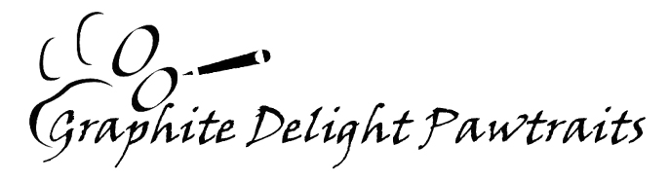

Please fill out this order form online and send it by email, along with your agreed high resolution photo(s) to **GraphiteDelightPawtraits@Hotmail.com**. Please ensure you have contacted me by email prior to sending to assess the suitability of your photo(s) and ensure I can fulfil your order.

|  |
| --- |
| **Name:** Click here to enter name **Delivery Address:** Click here to enter address  **Post code / zip code**: Click here to enter post/zip code  **Country:** Click here to enter country  **Contact tel:** Click here to enter telephone number **Contact email:** Click here to enter email address  *Please ensure that contact details are where I can contact you without alerting the recipient if a gift.*  Please check box as appropriate*  *Yes, it’s okay to freely contact me if required  *Please be discreet when contacting me |
| Please indicate number of photos included with order Click here to enter number   * Emailed  Is this the email address above? Yes  No * If no, please detail email photos emailed from: Click here to enter email address * Posted |

***I wish to order an original, hand drawn pet portrait as indicated below:***

|  |  |  |  |
| --- | --- | --- | --- |
| **PORTRAIT** | **MOUNT** | **P&P PER ORDER** | ***TOTAL*** |
| ***£120*** | ***Included*** | ***£9*** |
| *One animal*  *A4 with a plain background* | *Cream or Grasmere Green*  *(see website for colours)* | *Flat packed & fully insured* |
| Number | Cream  Green |  | Click here |
| Click here |  |

***If you're located outside the UK please contact me regarding postage costs.***

|  |  |
| --- | --- |
| Date portrait required | Click here to enter a date |

|  |  |
| --- | --- |
| Any other information regarding your commission? | Click here to enter text |

|  |  |
| --- | --- |
| Where did you find out about Graphite Delight Pawtraits? | Click here to enter text |

|  |  |  |
| --- | --- | --- |
| **Please total the price of your order including postage costs.** | | **£**Click here |
| **Deposit paid £50 (I will confirm receipt by email).** | | **£50** |
| **On completion of the portrait you then pay the balance.** | **TOTAL TO PAY** | **£**Click here |

SIGNED: Click here to enter name. DATE: Click here to enter a date.

I’ll get in touch to confirm your order.***Thanks for your commission!***

|  |
| --- |
| IMPORTANT NOTE: The information you provide will only be used for contacting you in connection with your order, and any related special offers. Your details will never be passed on to any third party. |